Retail Sales Data Analysis
End-to-End Data Analytics Project

Tools Used :
- Microsoft Excel
- Power Query
- Microsoft SQL Server
- Power BI

Project Workflow :
Raw Data → Data Cleaning → Analysis → Visualization → Business Insights

Executive Summary
This project analyzes retail sales data to understand sales performance, profitability, customer behavior, discounts, product performance, regional performance, and order returns. SQL was used to clean, aggregate, and analyze the data, while Power BI was used to create interactive dashboards and visualize key business metrics.
The analysis identified several important business patterns. Electronics generated the highest sales, while Beauty achieved the highest profit margin. Regional analysis showed that the South region generated the highest sales and profit, while the Central region recorded the highest profit margin. The analysis also identified seven high-sales but low-margin products, highlighting opportunities to improve profitability.
Customer analysis showed that a small group of customers generated substantially higher sales than the average customer. Most importantly, customer satisfaction showed a strong relationship with returns: customers with a satisfaction score of 1 had a 24.31% return rate, compared with only 6.61% for customers with a score of 5.
Overall, the findings provide actionable insights into where the business generates revenue, where profitability can be improved, which customers are most valuable, and how customer satisfaction is associated with product returns.

1. Introduction :
1.1 Project Background:
Retail businesses generate large amounts of transactional data, including sales, profits, customer information, discounts, shipping costs, satisfaction scores, and product returns. Analyzing this data helps businesses understand their performance and identify opportunities for improvement.
This project analyzes a retail sales dataset to identify important patterns in sales performance, profitability, customer behavior, product performance, regional performance, discounts, and returns.

1.2 Project Objective:
The main objective of this project is to use data analysis to answer important business questions and convert raw retail transaction data into actionable business insights.
The analysis focuses on:
- Understanding overall sales and profit performance
- Identifying the most profitable categories and regions
- Identifying high-value customers
- Evaluating the relationship between discounts and profitability
- Identifying high-sales but low-margin products
- Understanding customer satisfaction and return behavior
- Identifying areas where the business can improve profitability and customer experience

1.3 Tools Used:
Tool | Purpose
SQL | Data analysis, aggregation, filtering, and business-question analysis
Power BI | Dashboard creation and data visualization
DAX | Creating measures and calculated business metrics

  - Business Questions :
- Which product categories generate the most sales and profit?
- Which regions perform best?
- Which products have high sales but low profit margins?
- How do discounts relate to profitability?
- Who are the highest-value customers?
- How are sales changing over time?
- Which months generate the highest and lowest sales?
- What is the overall return rate?
- Which products and categories have high return rates?
- Does shipping cost affect profitability?
- How do customer satisfaction levels relate to returns?
- Which regions and categories have higher shipping costs?

2. Dataset Overview :
The dataset contains retail transaction-level information covering customer details, orders, products, sales, profit, discounts, shipping, customer satisfaction, returns, and order status.
The dataset was first reviewed and cleaned using Power Query before being used for analysis. The cleaned dataset was then used in Microsoft SQL Server for both basic and advanced analysis and was connected to Power BI for interactive visualization.
2.1 Key Data Fields :
Category | Important Fields
Order Information | order_id, order_date, order_status
Customer Information | customer_id, customer_name, age, gender
Location | region, city
Product Information | product_category, product_name
Sales | quantity_final, unit_price, discount_final, sales_amount
Profitability | profit, shipping_cost
Customer Experience | customer_satisfaction_final, return_flag
Shipping | day_to_ship_final

2.2 Data Analysis Workflow :
The project followed a structured data analytics workflow:
Raw Dataset → Power Query Cleaning → Cleaned Dataset → SQL Analysis → Power BI Visualization → Business Insights
3. Data Cleaning & Preparation :
The raw retail dataset was cleaned and prepared using Power Query before performing the SQL analysis and Power BI visualization. The cleaning process focused on identifying invalid values, handling missing values, removing duplicate and blank records, and ensuring that each field had the appropriate data type.

3.1 Data Cleaning Rules :

Field | Data Quality Issue | Cleaning Method | Reason
Age | Values below 18 were considered invalid and missing values were present. | Invalid values were converted to null and missing values were replaced using the median age. | The median provides a robust estimate and reduces the effect of extreme values.
Quantity | Missing values and very small/invalid quantities were present. | Invalid values were converted to null and missing values were replaced using the median quantity. | Prevents invalid quantities from affecting sales and order analysis.
Discount | Invalid discount values were identified. | Invalid values were converted to null and missing values were replaced using the median discount. | Ensures discount calculations use reasonable values.
Customer Satisfaction | Missing values were present. | Missing values were replaced using the median satisfaction score. | Maintains a representative satisfaction value without being strongly affected by outliers.
Days to Ship | Missing and unusually high values such as 45 and 100 days were identified. | Invalid values were converted to null and missing values were replaced using the median shipping time. | Prevents unrealistic shipping times from distorting operational analysis.
Shipping Cost | Missing/invalid shipping-cost values were identified | Invalid values were converted to null and missing values were replaced using the median shipping cost. | Provides a reasonable estimate while reducing the effect of extreme shipping costs.
Duplicates | Duplicate records were present. | Duplicate rows were removed using Power Query's Remove Duplicates function. | Prevents transactions from being counted more than once.
Blank Rows | Completely blank records were present. | Blank rows were removed using Remove Blank Rows. | Empty records provide no analytical value.
Data Types | Some fields required type corrections. | Data types were manually reviewed and changed to appropriate types. | Ensures dates, numbers, text, percentages, and logical values are processed correctly.

3.2 Data Preparation Process :
After cleaning the individual fields, the cleaned values were used to create final analytical columns such as age_final, quantity_final, discount_final, customer_satisfaction_final, and day_to_ship_final. These final fields were used in subsequent SQL analysis and Power BI visualizations.
Duplicate records and completely blank rows were removed, and the final dataset was checked to ensure that the required fields had appropriate data types.
Raw Data → Identify Issues → Convert Invalid Values to Null → Calculate Median → Replace Missing Values → Remove Duplicates/Blank Rows → Validate Data Types → Final Cleaned Dataset

4. SQL Analysis
After completing the data-cleaning process, the cleaned dataset was imported into Microsoft SQL Server for structured analysis. SQL was used to answer business questions through aggregations, filtering, Common Table Expressions (CTEs), window functions, conditional logic, and calculated metrics.
The analysis was divided into Basic Analysis and Advanced Analysis. Basic analysis was used to understand overall sales, profit, customer, regional, discount, and return patterns. Advanced analysis was then performed to identify deeper business trends and relationships.

4.1 Basic SQL Analysis :
The basic analysis focused on understanding the overall performance of the retail business.
Business Question | SQL Analysis
Which category generates the most sales? | Total sales were aggregated by product category.
Which category generates the most profit? | Total profit was aggregated by product category.
Which region performs best? | Sales and profit were compared across regions.
Which region has the highest profit margin? | Profit margin was calculated for each region.
Which products sell the most? | Products were ranked by total quantity sold.
Which category has the best profit margin? | Profit margin was calculated and compared across categories.
How do discounts relate to profit? | Sales, profit, order volume, and profit margin were compared across discount groups.
How are customers behaving? | Customer satisfaction, order frequency, and customer revenue were analyzed.
Are less-satisfied customers more likely to return orders? | Return rates were compared across satisfaction scores.
Are returns a problem? | Overall, category-level, and product-level return rates were calculated.

4.2 Advanced SQL Analysis :
Advanced SQL techniques were used to move beyond basic aggregation and identify more actionable business insights.

Business Question | Advanced SQL Technique
Who are the Top 10 Customers by Revenue? | TOP 10, GROUP BY, aggregation and sorting
Are the highest-revenue customers also the most profitable? | Customer-level sales and profit comparison
Which products have high sales but low profit? | CTE with product-level performance metrics
Are discounts contributing to low profit margins? | Product-level discount and profit-margin comparison
Which categories have high sales but poor profit margins? | CTE and profitability thresholds
How are sales changing month-to-month? | CTE + LAG() window function
Which months generated the highest and lowest sales? | CTE + MAX() / MIN()
How do customers rank based on total revenue? | RANK() window function
What percentage of total sales comes from each category? | Window function using SUM() OVER()
Who are the high-value customers? | Customer-level aggregation compared against average revenue
Customer-level aggregation compared against average revenue | CTE + conditional aggregation + average return rate
Does higher shipping cost affect profit? | Product-level shipping cost and profit comparison

4.3 SQL Techniques Used :
The SQL analysis demonstrated the use of several analytical SQL techniques, including:
- GROUP BY for aggregating sales, profit, orders, and other metrics.
- CASE WHEN for conditional calculations such as return analysis.
- CTEs (Common Table Expressions) for breaking complex analysis into manageable steps.
- LAG() for month-over-month sales comparison.
- RANK() for customer ranking.
- Window functions for calculating averages and sales contribution.
- TOP for identifying top-performing customers and products.
- NULLIF() to prevent division-by-zero errors.
- Calculated metrics such as profit margin, return rate, and sales contribution percentage.

5. Exploratory Data Analysis & Key Findings
5.1 Overall Sales & Profitability :
Finding - Overall Sales and Profitability :
The analysis of overall sales and profitability provides a baseline for evaluating the business's financial performance. Total sales and total profit were calculated from the transaction-level data, with profit margin used to measure how efficiently sales were converted into profit.
The overall performance metrics provide the foundation for comparing product categories, regions, and individual products throughout the analysis.

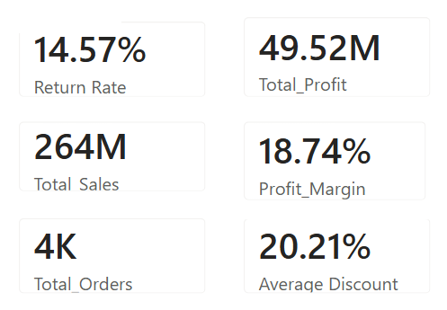

Business Insight :
These overall KPIs establish the baseline for the analysis. The subsequent category, regional, product, discount, and customer analysis helps identify the areas contributing most to sales and profit and the areas where performance can be improved.

5.2 Category Performance
Finding - Electronics Drives Sales, While Beauty Has the Highest Profit Margin:
Electronics was the strongest category in terms of sales, generating approximately ₹155.64 million, significantly higher than the other categories. However, its profit margin was only 12.28%.
In contrast, Beauty recorded the highest profit margin at 45.06%, despite generating only ₹3.88 million in sales. Clothing and Books also achieved relatively high profit margins of 36.16% and 37.21%, respectively.
Groceries had the lowest profit margin at 7.85%, indicating relatively weak profitability compared with the other categories.

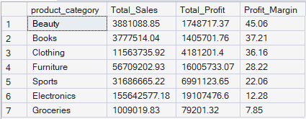

Business Insight :
The results show that high sales volume does not necessarily mean high profitability. Electronics is the main revenue driver, but its relatively low margin suggests an opportunity to investigate pricing, discounts, product costs, and other expenses. Meanwhile, high-margin categories such as Beauty, Clothing, and Books could offer opportunities for profitable growth.

5.3 Regional Performance
Finding - South Leads in Sales, While Central Has the Highest Profit Margin
The South region generated the highest sales at approximately ₹73.52 million and also recorded the highest total profit of ₹13.26 million. However, its profit margin was 18.04%.
The Central region generated the lowest sales among the five regions at ₹40.67 million, but achieved the highest profit margin at 20.37%. The North region generated ₹53.61 million in sales with a 19.36% profit margin, while West and East recorded profit margins of 18.48% and 18.01%, respectively.

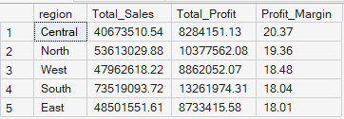

Business Insight :
The regional results indicate that sales volume and profitability efficiency are not necessarily aligned. South is the strongest region in terms of revenue and total profit, while Central is the most efficient in converting sales into profit. This suggests that the business could investigate the factors behind Central's higher margin and determine whether similar practices can be applied to higher-volume regions.

5.4 Product Profitability
Finding - High Sales but Low Profitability Products
The purpose was to identify products that:
- Generate above-average sales
- But generate below-average profit
These products are important because they can generate significant revenue while contributing less profit than expected.

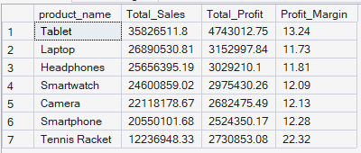

Business Insight :
The analysis identified a group of products with high sales but relatively low profitability. These products should be investigated further to understand whether low margins are caused by high discounts, product costs, shipping costs, or pricing decisions.
This finding highlights an important distinction between revenue performance and profitability. A product can sell very well but still provide limited profit to the business.

5.5 Discount & Profitability
Finding 5 — Higher Discounts Do Not Automatically Reduce Profit Margin
The analysis shows that the highest discount group (30%+) recorded a profit margin of 19.53%, while the lowest discount group (0–10%) recorded a margin of 18.09%.
This indicates that, in this dataset, higher discounts did not directly correspond to lower profit margins. The 20–30% discount group also maintained a relatively strong margin of 19.03%.
However, the 0–10% discount group generated the highest sales (₹81.89 million) and the highest total profit (₹14.81 million) because of its larger sales volume.

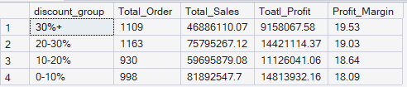

Business Insight :
Discount percentage alone does not appear to explain profitability. Other factors such as product category, product cost, sales volume, and shipping costs may also influence profit margins.
Therefore, the business should avoid assuming that reducing discounts will automatically increase profitability. Discount decisions should instead be evaluated alongside sales volume and profit margin.

5.6 Customer Analysis
Finding 6 — High-Value Customers
The customer analysis identified customers whose total sales were higher than the average customer sales. These customers represent the business's high-value customer segment and contribute significantly to overall revenue.
The top customer generated approximately ₹17.37 million in sales, followed by the second-highest customer at approximately ₹7.94 million. The remaining high-value customers generated substantially lower sales, showing that customer contribution is highly uneven.
This indicates that a relatively small group of customers can contribute a significant amount of revenue, making them important for customer retention and relationship management.

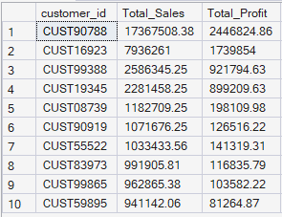

Business Insight
The large difference between the highest-value customers suggests that customer revenue is not evenly distributed. The business should prioritize retention, personalized offers, loyalty programs, and relationship management for high-value customers.

5.7 Customer Satisfaction & Returns
Finding 7 — Lower Customer Satisfaction Is Associated with Higher Return Rates
The analysis shows a clear relationship between customer satisfaction and return rates. Customers with a satisfaction score of 1 had the highest return rate at 24.31%, while customers with a satisfaction score of 5 had the lowest return rate at 6.61%.
The return rate consistently decreases as customer satisfaction increases. This suggests that less-satisfied customers are more likely to return their orders.

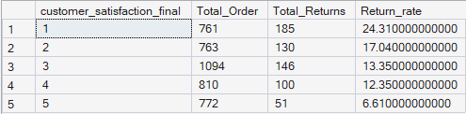

Business Insight :
The strong difference in return rates indicates that customer satisfaction may be an important factor associated with product returns. The business should investigate the reasons behind low satisfaction, such as product quality, product expectations, delivery experience, or other customer-service issues.

6. Power BI Dashboard
6.1 Dashboard Overview
Power BI Dashboard
An interactive Power BI dashboard was developed to present the key findings from the retail sales analysis in a clear and business-friendly format.
The dashboard combines KPIs, charts, tables, and filters to help users quickly understand sales performance, profitability, customer behavior, product performance, regional performance, discounts, and returns.
The dashboard was designed to allow business users to explore the data interactively and identify areas that require attention.

Dashboard Objectives
The dashboard was created to:
- Monitor overall sales and profit performance
- Analyze profitability across product categories
- Compare regional performance
- Identify high-value customers
- Analyze product sales and profitability
- Understand the relationship between discounts and profit margin
- Identify products with high sales but relatively low profitability
- Monitor shipping costs relative to sales
- Analyze customer satisfaction and return behavior

Dashboard Structure
The Power BI report contains multiple pages, with each page focusing on a different aspect of the business.

Dashboard Page | Purpose
Page 1 — Executive Overview | Overall sales, profit, margin, orders, and returns
Page 2 — Customer & Order Analysis | Customer value, orders, satisfaction, and customer behavior
Page 3 — Product & Profitability Analysis | Product performance, profitability, discounts, and shipping costs
Page 4 — Detailed Analysis | Additional analytical views and supporting findings


6.2 Page 1 - Executive Overview :
The Executive Overview dashboard provides a high-level view of the company's overall retail performance. It brings together key performance indicators and visualizations to help users quickly understand sales, profitability, orders, returns, and overall business trends.
Key Performance Indicators :



Key Visualizations
The dashboard also provides visual analysis of:
- Sales & Profit Margin by Category — compares category revenue with profitability.
- Sales & Profit by Region — compares regional sales and profit performance.
- Sales Trend — shows how sales change over time.
- Category / Product Performance — helps identify strong and weak areas of the business.

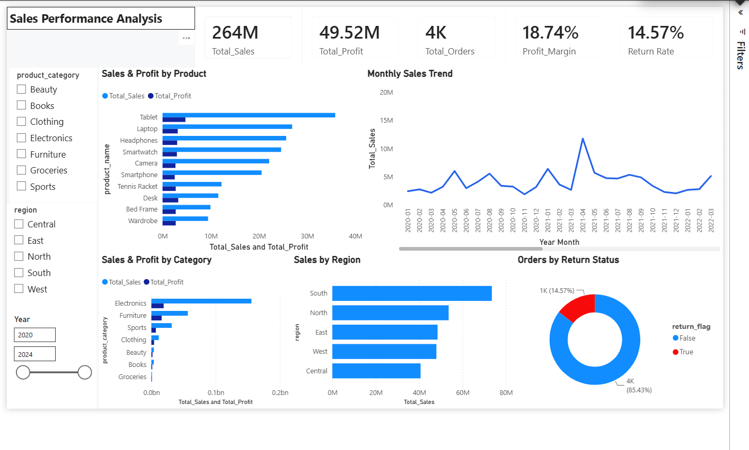

Figure 1: Power BI Executive Overview Dashboard

6.3 Page 2 - Customer & Order Analysis :
The Customer & Order Analysis dashboard provides a detailed view of customer behavior and order performance. The dashboard helps identify high-value customers and understand overall customer activity.
The page includes KPIs for:
- Total Orders
- Unique Customers
- Average Order Value
- Return Rate
- Average Customer Satisfaction
These KPIs provide an overview of customer activity, order value, and customer experience.
Customer Analysis
The dashboard includes a Top 10 Customers by Revenue visualization to identify customers who generate the highest sales.
This analysis helps the business:
- Identify high-value customers
- Understand customer revenue concentration
- Support customer retention strategies
- Identify customers who may be suitable for targeted offers or loyalty programs

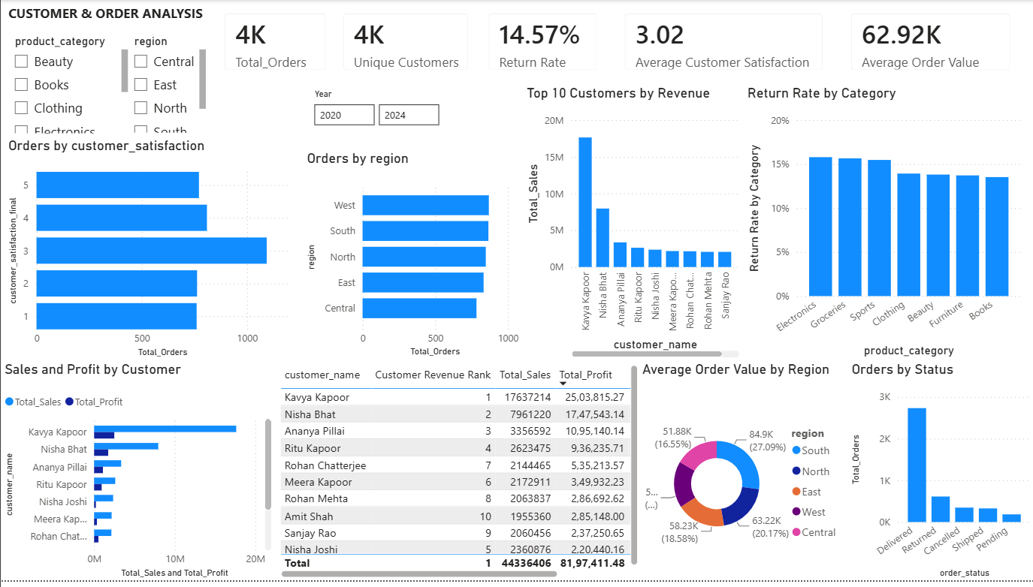
Figure 2: Power BI Customer & Order Analysis Dashboard
6.4 Page 3 - Product & Profitability Analysis
The Product & Profitability dashboard provides a detailed view of product-level performance. It helps identify products and categories that generate strong sales, as well as areas where profitability may require improvement.
Key Analysis
The dashboard focuses on:
- Product Sales & Profitability — compares products based on sales and profit.
- Sales & Profit Margin by Category — evaluates category-level profitability.
- Discount vs Profit Margin — examines the relationship between discount levels and profit margins.
- High Sales / Low Profit Products — identifies products generating strong sales but relatively low profit.
- Shipping Cost % of Sales — highlights products where shipping costs represent a significant portion of sales.
Business Use
These analyses help the business understand whether strong sales are translating into healthy profits. They also provide areas for further investigation, including discounting, product costs, and shipping expenses.

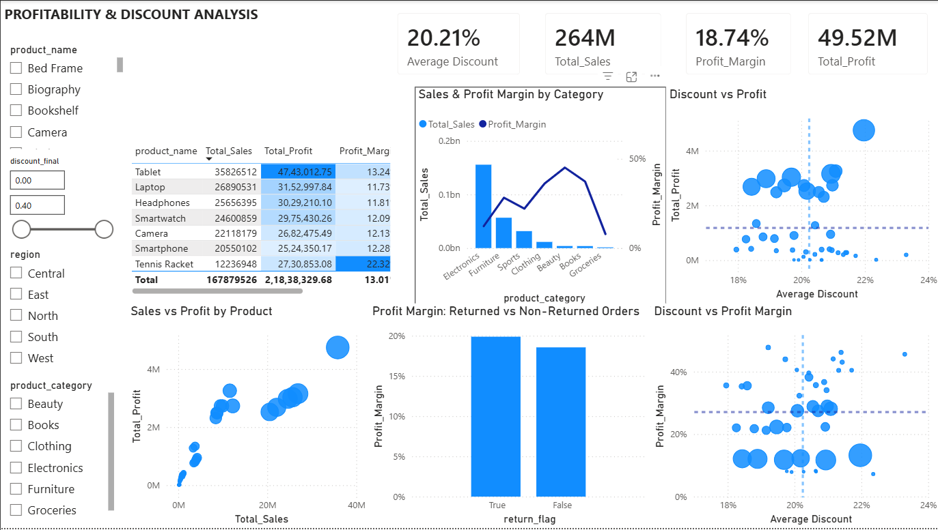
Figure 3: Power BI Product & Profitability Analysis Dashboard
6.5 Page 4 - Detailed Analysis
Page 4 provides additional analytical views that support the findings identified during the SQL analysis. These visuals allow users to investigate specific areas of product, profitability, and operational performance in greater detail.



Figure 4: Power BI Detailed Analysis Dashboard

6.6 Page 5 - Operations & Shipping Analysis:
The Operations & Shipping Analysis dashboard focuses on the operational factors that can affect overall business performance, particularly shipping costs and order-related performance.
The dashboard helps identify areas where shipping expenses may have a significant impact on sales and profitability.
Key Analysis
The page focuses on:
- Shipping Cost % of Sales — measures shipping costs relative to sales.
- Identifying products or areas with high shipping cost impact.
- Comparing operational performance across relevant products or categories.
- Supporting the identification of areas where operational costs could be reduced.
Business Use
This analysis helps the business understand how shipping expenses affect overall profitability. Products with a high shipping-cost-to-sales ratio may require further investigation to determine whether shipping policies, product pricing, or fulfillment processes can be improved.

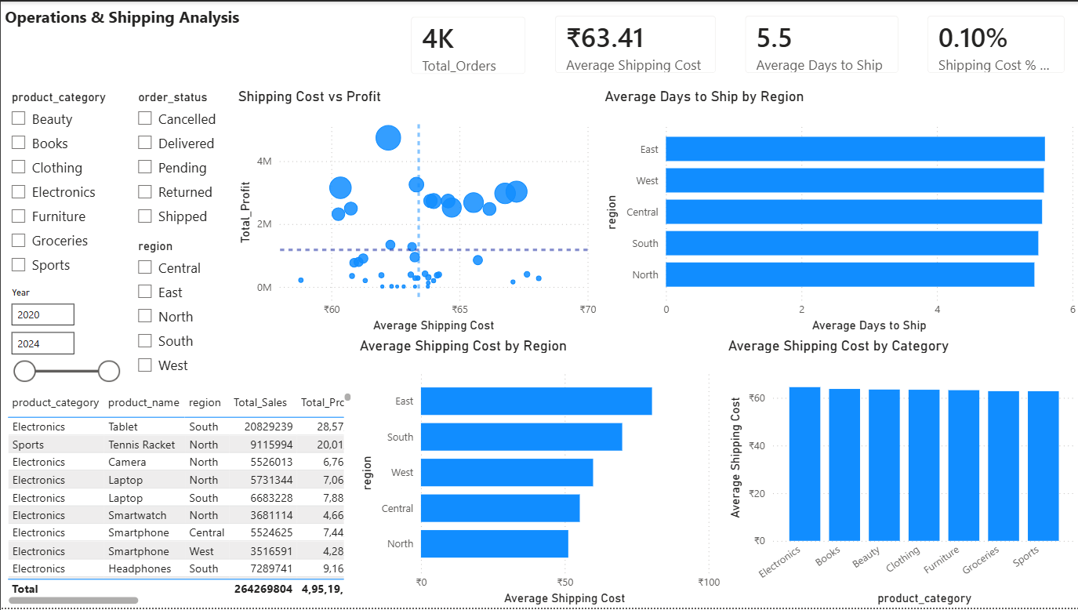

Figure 5: Power BI Operations & Shipping Analysis Dashboard
7. Business Recommendations
7.1 Improve Profitability in High-Sales Categories
Electronics generated the highest sales at approximately ₹155.64M and the highest total profit at ₹19.11M, but its profit margin was only 12.28%.
Recommendation:
Review pricing, product costs, discounts, and shipping expenses within the Electronics category to identify opportunities to improve margins without reducing sales volume.
7.2 Expand High-Margin Categories
Beauty achieved the highest profit margin at 45.06%, followed by Books at 37.21% and Clothing at 36.16%.
Recommendation:
Consider increasing the visibility, product selection, and marketing of high-margin categories where there is potential for additional sales growth.
7.3 Investigate Regional Profitability
The South region generated the highest sales at ₹73.52M, while the Central region achieved the highest profit margin at 20.37% despite having the lowest regional sales.
Recommendation:
Investigate what makes the Central region more profitable and determine whether its successful pricing, product mix, or cost structure can be applied to higher-volume regions.
7.4 Review High-Sales / Low-Profit Products
The analysis identified products that generate above-average sales but below-average profit.
Recommendation:
Review these products for high costs, excessive discounts, pricing issues, and shipping expenses. Improving their margins could increase profitability without requiring additional sales.
7.5 Optimize Discount Strategies
The analysis showed that discount level alone did not have a simple negative relationship with profit margin. The 30%+ discount group had a 19.53% margin, compared with 18.09% for the 0–10% group.
Recommendation:
Instead of applying a blanket discount strategy, evaluate discounts together with product category, sales volume, product cost, and profitability.
7.6 Focus on High-Value Customers
The customer analysis identified customers generating sales significantly above the average customer level. The highest-value customer generated approximately ₹17.37M in sales.
Recommendation:
Develop customer-retention strategies such as personalized offers, loyalty programs, and targeted communication for high-value customers.
7.7 Reduce Returns by Improving Customer Satisfaction
The strongest relationship identified in the analysis was between customer satisfaction and returns. Customers with a satisfaction score of 1 had a 24.31% return rate, compared with only 6.61% for customers with a satisfaction score of 5.
Recommendation:
Investigate the causes of low satisfaction, including product quality, product expectations, delivery experience, and customer service. Improving these areas may help reduce returns and improve customer retention.
7.8 Monitor Shipping Costs
Shipping costs should be monitored relative to sales because high shipping expenses can reduce product-level profitability.
Recommendation:
Identify products with a high Shipping Cost % of Sales and investigate opportunities to optimize shipping methods, fulfillment processes, packaging, or pricing.

8. Conclusion
- This project analyzed retail sales data using SQL, Power BI, and DAX to understand overall business performance, profitability, customer behavior, product performance, regional performance, discounts, shipping costs, and returns.
- The analysis showed that Electronics was the largest sales-generating category, while Beauty had the highest profit margin. At the regional level, South generated the highest sales and total profit, whereas Central achieved the highest profit margin.
- The product analysis highlighted the importance of distinguishing between high sales and high profitability, as some products generated strong sales but relatively lower profits. The discount analysis also showed that higher discounts did not automatically result in lower profit margins, indicating that profitability is influenced by multiple factors.
- Customer analysis identified a group of high-value customers who contribute significantly to revenue. Most importantly, the analysis found a clear relationship between customer satisfaction and return rates: lower satisfaction scores were associated with substantially higher return rates.
- The Power BI dashboard transformed these findings into interactive visualizations that allow business users to explore performance and identify areas requiring attention.
- Overall, this project demonstrates how SQL can be used to investigate business questions, Power BI can communicate analytical findings, and data-driven insights can be translated into practical business recommendations.

Key Takeaways
- Electronics is the major sales driver but has a relatively low profit margin.
- Beauty has the highest profit margin at 45.06%.
- South leads in total sales and profit.
- Central has the highest regional profit margin at 20.37%.
- High sales do not always mean high profitability.
- Discount levels should be evaluated alongside other profitability factors.
- High-value customers represent an important customer-retention opportunity.
- Customer satisfaction has a strong association with return rates.
- Shipping costs should be monitored because they can affect product profitability.

9. Appendix — SQL Analysis
9.1 Purpose of the SQL Analysis
SQL was used to analyze the retail transaction data and answer the project's key business questions. Queries were developed using aggregations, filtering, conditional logic, Common Table Expressions (CTEs), window functions, and calculated metrics.
The SQL analysis formed the foundation for the business findings presented in this report and supported the development of the Power BI dashboard.
9.2 SQL Queries
Query 1 - Overall Sales & Profitability
SELECT product_category,
ROUND(SUM(sales_amount),2) AS Total_Sales,
ROUND(SUM(profit),2) AS Total_Profit,
ROUND(SUM(profit) * 100.0 / SUM(sales_amount),2) AS Profit_Margin
FROM retail_sales_dataset_CLEANED
GROUP BY product_category
ORDER BY Profit_Margin DESC
Query 2 - Sales & Profitability by Category
SELECT product_category,
ROUND(SUM(sales_amount),2) AS Total_Sales,
ROUND(SUM(profit),2) AS Total_Profit
FROM retail_sales_dataset_CLEANED
GROUP BY product_category
ORDER BY Total_Sales DESC
Query 3 - Regional Performance
SELECT region, SUM(sales_amount) AS Total_Sales,
SUM(profit) AS Total_Profit
FROM retail_sales_dataset_CLEANED
GROUP BY region
ORDER BY Total_Profit DESC
Query 4 - Product Profitability
SELECT product_name,
ROUND(SUM(sales_amount),2) AS Total_sales,
ROUND(SUM(profit),2) AS Total_profit
FROM retail_sales_dataset_CLEANED
GROUP BY product_name
ORDER BY Total_profit DESC
Query 5 - Discount & Profitability
SELECT discount_group, COUNT(order_id) AS Total_Order,
ROUND(SUM(sales_amount),2) AS Total_Sales,
ROUND(SUM(profit),2) AS Toatl_Profit,
ROUND(SUM(profit) * 100.0/ NULLIF(SUM(sales_amount),0),2) AS Profit_Margin
FROM retail_sales_dataset_CLEANED
GROUP BY discount_group
ORDER BY Profit_Margin DESC
Query 6 - High-Value Customers
WITH Customer_Sales AS
( SELECT customer_id,
ROUND(SUM(sales_amount),2) AS Total_Sales
FROM retail_sales_dataset_CLEANED
GROUP BY customer_id ),
Average_Tootal_Sales AS
( SELECT customer_id,Total_Sales,
ROUND(AVG(Total_Sales) OVER(),2) AS Average_Total_Sales
FROM Customer_Sales )
SELECT customer_id,Total_Sales
FROM Average_Tootal_Sales
WHERE Total_Sales > Average_Total_Sales
ORDER BY Total_Sales DESC
Query 7 - Customer Satisfaction & Returns
SELECT customer_satisfaction_final,
COUNT(order_id) AS Total_Order,
SUM(CASE WHEN return_flag = 1 THEN 1 ELSE 0 END) AS Total_Returns,
ROUND(SUM(CASE WHEN return_flag = 1 THEN 1 ELSE 0 END) * 100.0 / NULLIF(COUNT(order_id),0),2) AS Return_rate
FROM retail_sales_dataset_CLEANED
GROUP BY customer_satisfaction_final
ORDER BY customer_satisfaction_final
9.3 SQL Techniques Used :
The analysis used several SQL techniques, including:
- SUM() and AVG() for aggregating sales, profit, and other metrics
- COUNT() for order and customer analysis
- GROUP BY for category, region, product, and customer-level analysis
- CASE WHEN for conditional calculations
- NULLIF() to avoid division-by-zero errors
- Common Table Expressions (WITH) for structuring complex analyses
- Window functions such as AVG() OVER() for customer-level comparisons
- ORDER BY and filtering to identify high-performing and underperforming segments

